

 | 
 | 
 | 
 | MD Razia
 | P. Teja
 | 2520030569
 | CSE
 | Co-2

Case Study topic: Flipkart Product Search and Indexing using B+ Trees

Work Done Summary:
In this case study, we implemented a Flipkart Product Search and Indexing System using a B+ Tree. The B+ Tree stores product IDs in sorted order and supports efficient search, insertion, and retrieval operations. Since all product records are maintained at the leaf level, the system enables fast database indexing and range-based product searches. B+ Trees are widely used in e-commerce platforms to manage large product catalogs efficiently.

Implementation Details:
- Implemented a B+ Tree to store product IDs.
- Inserted product records into the tree.
- Maintained sorted indexing of products.
- Performed node splitting whenever a node became full.
- Stored all product records in leaf nodes.
- Implemented efficient search operations.
- Supported range queries through linked leaf nodes

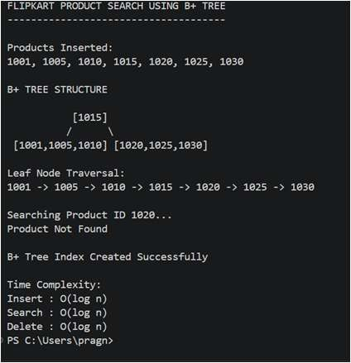
.Results and Screenshots:
The Flipkart Product Search System was successfully implemented using a B+ Tree. Product records were indexed efficiently, enabling fast search and retrieval operations. The search for Product ID 1020 was completed successfully, demonstrating efficient database indexing.

GitHub Link:

 | 

